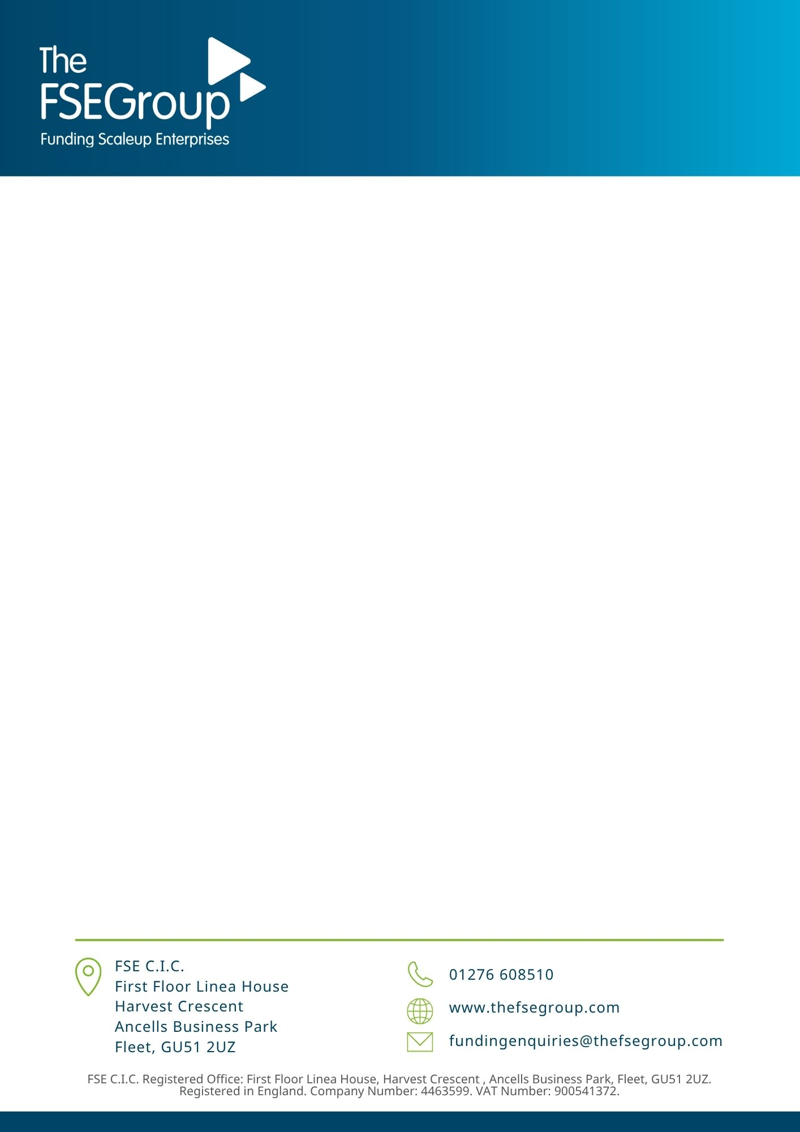

FSE INVESTOR NETWORK

Investor Registration Form
The information in the registration form will used for administrative purposes. All information will be used in line with our Angel Investors privacy notice, a copy of which has been supplied and can also be found on our website.

Contact details of Investor

Title

First name

Surname

Address

Postcode

Telephone number

Email address

Company
Position
Website
Declaration and Application:

I confirm that the information provided above and with this application is accurate and complete.

I accept that FSE C.I.C. and its associated organisations reserve the right to refuse membership at its absolute
discretion.

I accept that the role of The Investor Network and associated organisations is to link firms seeking investment with potential investors. The activities under The Investor Network and its associated organisations are exempt from Authorisation under the Financial Services and Markets Act 2000.

I understand that The Investor Network and associated organisations are not authorised under the Financial Services and Markets Act 2000 to give advice on the merits of any investment or to carry out any other form of regulated investment activity.

I consent to being informed of possible investment opportunities by telephone or other convenient means.

I accept that no responsibility can be accepted by The Investor Network or any associated organisations for any damage or loss of whatever nature due to negligence, disclosure, or non-disclosure or, any cause occasioned by me/us or by a business registered as an investee (whether an individual, partnership, unincorporated business or incorporated company) acting upon information provided under the scheme.

I acknowledge that The Investor Network and its associated organisations have drawn to my/our
attention the following statement:

“Investment in new businesses and existing private business carries high risks, as well as the
possibility of high rewards. It is highly speculative and potential investors should be aware that
no established market exists for the trading of shares in private companies. Before investing in a
project about which information is given, potential investors are strongly advised to take advice
from a person authorised under the Financial Services and Markets Act 2000 who specialises in
advising on investments of this kind, and in particular the implications for any taxation
advantages and conditions. Potential investors should carry out their own due diligence into the
opportunities presented to them.”

I confirm that I am a self-certified High Net Worth or Sophisticated Investors as defined by the FSMA 2000. If there are any changes to my circumstances where I could no longer be categorised as a self
certified high net worth individual, I will inform the FSE Investor Network immediately.

I agree to re-confirming my status as a self-certified high net worth individual when required by the FSE Investor Network.
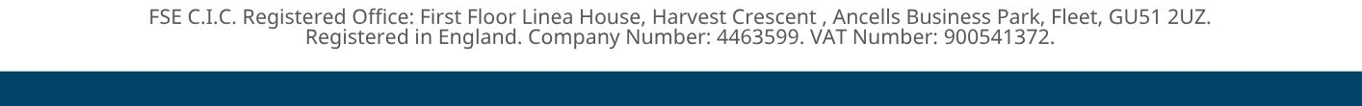
I accept that The FSE Investor Network or its associated organisations, at their sole discretion, reserve the right to suspend or discontinue its services for whatever reason at any time.

I understand that proposals for investment are submitted in confidence to investors registered with the FSE
Investor Network and that any and all information on these proposals provided to me is provided on the understanding that such information will be held confidential to myself and my advisers and will
not be communicated to any other person, including in particular other investor networks, nor will it be used for any purpose other than in connection with considering whether or not I should enter into discussions and seek further information with a view to providing funds to the business which the proposals describe.

I acknowledge and understand that any business introduced through The Investor Network or associated organisations, in which I/we may invest, would be liable to pay The FSE Investor Network a success fee as agreed with the Company. I/we agree to inform The FSE Investor Network within 7 days of any such investments.

Signed : ………………………………………… ……………………….................. Date: ………… (Please print name)
Description of interests:

Please provide a brief resume of your background/career and outline your major motivations for making investments.

Date of last investment: _____________________

Amount invested in new investments in last 2 years __________________________

No of investments in last 2 years ________________

Funds Available: ________________

Range of investment size: Minimum: ______________ Maximum: ______________

Are you willing to become part of a syndicate? Yes No

Ideal stage of Business Development:
Pre-start Start up
Early Start Established
Turn round No Preference

Industry:
Communications Construction/Engineering
Dot Com/IT/Software Drink/Food
Electronic Environment
Health/Medical Hotels/Restaurants
Leisure/Entertainment Media
Pharmaceuticals/Biotech Printing/Publishing
Scientific Instruments Service
Transport No Preference

Please specify any excluded sectors/industries:

Please complete the applicable form; Sophisticated Investor OR HNW Individual
Please return completed forms to: Trevor Jones, The FSE Group, First Floor, Linea House, Harvest Crescent, Ancells Business Park, Fleet, Hampshire, GU51 2UZ
Email trevor.jones@thefsegroup.com

FSE Investor Network

ANNUAL Statement for Self‐Certified Sophisticated Investor

I declare that I am a self‐certified sophisticated investor for the purposes of the Financial Services and Markets Act 2000, COBS 4.12.7R01/01/2014RP

I understand that:
- I may receive financial promotions that may not have been approved by a person authorised by the Financial Conduct Authority (FCA);
- the content of such financial promotions may not conform to rules issued by the FCA;

by signing this statement, I may lose significant rights;
- I may have no right to complain to either of the following
- the Financial Conduct Authority;
- or the Financial Ombudsman Scheme;
- I may have no right to seek compensation from the Financial Services Compensation Scheme.

I am a self‐certified sophisticated investor because at least one of the following applies:
- I am a member of a network or syndicate of business angels and have been so for at least the last six months prior to the date below;
- I have made more than one investment in an unlisted company in the two years prior to the date below;
- I am working, or have worked in the two years prior to the date below, in a professional capacity in the private equity sector, or in the provision of finance for small and medium enterprises;
- I am currently or have been in the two years prior to the date below, a director of a company with an annual turnover of at least £1 million.

I accept that I can lose my property and other assets from making investment decisions based on financial promotions and that where I am making investments for taxation advantages, I need to ensure that all criteria is met and adhered to. I also acknowledge that where I am unsure of any of the proposals put to me, I will seek independent financial advice from someone who specialises in advising on such investments.

Sophisticated investor statement
I make this statement so that I can receive promotional communications which are exempt from the restrictions on financial promotions of non‐mainstream pooled investments. The exemption relates to certified sophisticated investors and I declare that I qualify as such.
I accept that the investments to which the promotions will relate may expose me to a significant risk of losing all of the money or other property invested. I am aware that it is open to me to seek advice from an authorised person who specialises in advising on non‐mainstream pooled investments.
I accept that the contents of promotions and other material that I receive may not have been approved by an authorised person and that their content may not therefore be subject to controls which would apply if the promotion were made or approved by an authorised person. I am aware that it is open to me to seek advice from someone who specialises in advising on this kind of investment.

Signature..................................................................................................... Date......................................
Print Name...................................................................................................

Please complete the applicable form; Sophisticated Investor OR HNW Individual
Please return completed forms to: Trevor Jones, The FSE Group, First Floor, Linea House, Harvest Crescent, Ancells Business Park, Fleet, Hampshire, GU51 2UZ
Email trevor.jones@thefsegroup.com

FSE Investor Network

ANNUAL Statement for Certified High Net Worth Individual

I declare that I am a certified high net worth individual for the purposes of the Financial Services and Markets Act 2000, COBS 4.12.6R10/10/2016RP

I make this statement so that I can receive promotional communications which are exempt from the restrictions on promotions of non‐mainstream pooled investments. The exemption relates to certified high net worth investors and I declare that I qualify as such because at least one of the following applies to me:

- I had, during the financial year immediately preceding the date below, an annual income to the value of £100,000 or more (not including money withdrawn from my pension savings, except where the withdrawal has been used directly for income in retirement);
- I held, throughout the financial year immediately preceding the date below, net assets to the value of
£250,000 or more. Net assets for these purposes do not include:
  - the property which is my primary residence, or any loan secured on that residence;
  - any rights of mine under a qualifying contract of insurance within the meaning of the Financial Services and Markets Act 2000; or,
  - any benefits (in the form of pensions or otherwise) which are payable on the termination of my service or on my death or retirement and to which I am (or my dependents are), or may be, entitled.
  - any withdrawals from my pension savings, except where the withdrawal has been used directly for income in retirement.

I understand that:
- I may receive financial promotions that may not have been approved by a person authorised by the Financial Conduct Authority (FCA);
- the content of such financial promotions may not conform to rules issued by the FCA;

by signing this statement, I may lose significant rights;
- I may have no right to complain to either of the following
- the Financial Conduct Authority;
- or the Financial Ombudsman Scheme;
- I may have no right to seek compensation from the Financial Services Compensation Scheme.

I accept that I can lose my property and other assets from making investment decisions based on financial promotions, and that where I am making investments for taxation advantages, I need to ensure that all criteria is met and adhered to.

I accept that the investments to which the promotions will relate may expose me to a significant risk of losing all of the money or other property invested. I am aware that it is open to me to seek advice from an authorised person who specialises in advising on non‐mainstream pooled investments.

Signature..................................................................................................... Date......................................

Print Name..................................................................................................

